**INFORMATION DISCLOSURE STATEMENT BY APPLICANT**

**(Form PTO/SB/08a)**

**Page 1 of 2**



**Application Number:** [TO BE ASSIGNED]

**Filing Date:** [CURRENT DATE]

**First Named Inventor:** Brian James Rutherford

**Art Unit:** [TO BE ASSIGNED]

**Examiner:** [TO BE ASSIGNED]

**Attorney Docket No:** RUTHERFORD-013_PROV

**Title of Invention:**

Federated Quantum Threat Intelligence Network with Privacy-Preserving Multi-Organization Protocols, Zero Trust Architecture, Quantum-Verified Incident Response with Optimized Latency, and Quantum Homomorphic Encryption



**U.S. PATENT DOCUMENTS**

*Note: To be supplemented during prosecution*

|  |  |  |  |  |
| --- | --- | --- | --- | --- |
| **Examiner Cite** | | **Patent** | **Kind** | **Issue** |
| **No.** | | **Number** | **Code** | **Date** |
|  |  |  |  |  |
|  |  |  |  |  |

**Name of Patentee or Applicant**

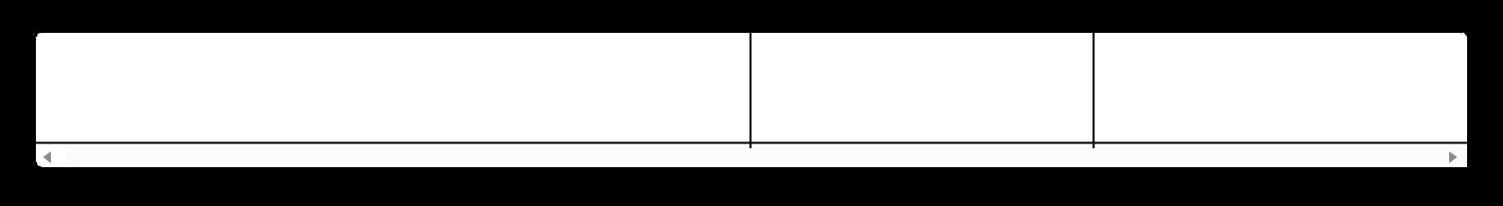

**Pages, Columns, Lines Referenced**

* None cited at this time



**FOREIGN PATENT DOCUMENTS**

*Note: To be supplemented during prosecution*

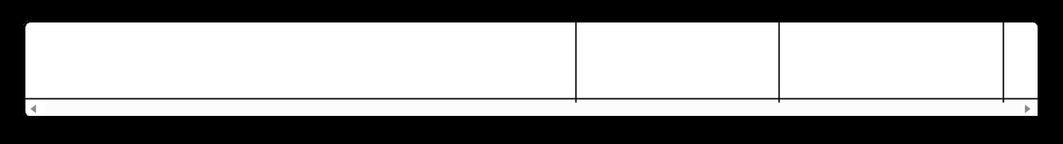

|  |  |  |  |  |
| --- | --- | --- | --- | --- |
| **Examiner** | | **Publication** | **Kind** | **Publication** |
| **Cite No.** | | **Number** | **Code** | **Date** |
|  |  |  |  |  |
|  |  |  |  |  |

**Name of Patentee or Applicant**

**Pages, Columns, Lines Referenced**

**T**

* None cited at this time



**NON-PATENT LITERATURE DOCUMENTS**



|  |  |  |  |  |  |
| --- | --- | --- | --- | --- | --- |
|  | **Examiner** | **Include name of the author (in CAPITAL LETTERS), title of the article, title of the item** |  |  |  |
|  | **(book, magazine, journal, etc.), date, pages, volume-issue number(s), publisher, city and/or** | **T** | |  |
|  | **Cite No.** |  |
|  | **country where published** |  |  |  |
|  |  |  |  |  |
|  |  | BENNETT, C.H. and BRASSARD, G., "Quantum cryptography: Public key distribution and coin |  |  |  |
|  | NPL-1 | tossing," Proceedings of IEEE International Conference on Computers, Systems and Signal |  |  |  |
|  |  | Processing, December 1984, pp. 175-179, IEEE, Bangalore, India |  |  |  |
|  |  | BROADBENT, A. and JEFFERY, S., "Quantum homomorphic encryption for circuits of low T-gate |  |  |  |
|  | NPL-2 | complexity," CRYPTO 2015, Lecture Notes in Computer Science, vol. 9216, pp. 609-629, 2015, |  |  |  |
|  |  | Springer, Berlin |  |  |  |
|  | NPL-3 | DULEK, Y., et al., "Quantum homomorphic encryption for polynomial-sized circuits," CRYPTO 2016, |  |  |  |
|  | Lecture Notes in Computer Science, vol. 9816, pp. 3-32, 2016, Springer, Berlin |  |  |  |
|  |  |  |  |  |
|  |  |  |  |  |  |
|  |  |  |  |  |  |
|  |  |  |  |  |  |



**Page 2 of 2**

|  |  |  |  |  |  |
| --- | --- | --- | --- | --- | --- |
|  | **Examiner** | **Include name of the author (in CAPITAL LETTERS), title of the article, title of the item** |  |  |  |
|  | **(book, magazine, journal, etc.), date, pages, volume-issue number(s), publisher, city and/or** | **T** | |  |
|  | **Cite No.** |  |
|  | **country where published** |  |  |  |
|  |  |  |  |  |
|  | NPL-4 | MAHADEV, U., "Classical Homomorphic Encryption for Quantum Circuits," SIAM Journal on |  |  |  |
|  | Computing, FOCS 2018 Special Issue, pp. 189-215, 2020, SIAM, Philadelphia |  |  |  |
|  |  |  |  |  |
|  |  | NIST, "Post-Quantum Cryptography Standards," Federal Information Processing Standards |  |  |  |
|  | NPL-5 | Publication, FIPS 203, 204, 205, August 2024, National Institute of Standards and Technology, |  |  |  |
|  |  | Gaithersburg, MD |  |  |  |
|  | NPL-6 | ETSI, "Quantum Key Distribution (QKD); Implementation Security: Protection Profile," ETSI GS QKD |  |  |  |
|  | 016 V1.1.1, 2023, European Telecommunications Standards Institute, Sophia Antipolis, France |  |  |  |
|  |  |  |  |  |
|  | NPL-7 | BEN-OR, M. and HASSIDIM, A., "Fast quantum byzantine agreement," Proceedings of the 37th |  |  |  |
|  | Annual ACM Symposium on Theory of Computing (STOC), pp. 481-485, 2005, ACM, New York |  |  |  |
|  |  |  |  |  |
|  | NPL-8 | GROVER, L.K., "A fast quantum mechanical algorithm for database search," Proceedings of the |  |  |  |
|  | 28th Annual ACM Symposium on Theory of Computing, pp. 212-219, 1996, ACM, Philadelphia |  |  |  |
|  |  |  |  |  |
|  |  | SHOR, P.W., "Algorithms for quantum computation: discrete logarithms and factoring," |  |  |  |
|  | NPL-9 | Proceedings of the 35th Annual Symposium on Foundations of Computer Science, pp. 124-134, |  |  |  |
|  |  | 1994, IEEE, Santa Fe |  |  |  |
|  |  | EINSTEIN, A., PODOLSKY, B., and ROSEN, N., "Can Quantum-Mechanical Description of Physical |  |  |  |
|  | NPL-10 | Reality Be Considered Complete?" Physical Review, vol. 47, pp. 777-780, 1935, American Physical |  |  |  |
|  |  | Society |  |  |  |
|  |  |  |  |  |  |
|  |  |  |  |  |  |



**EXAMINER'S SIGNATURE AND CONSIDERATION**

**Examiner Signature:** _________________ **Date Considered:** _________________



**APPLICANT'S CERTIFICATION**

**/Brian James Rutherford/** hereby certifies that each item of information contained in this Information Disclosure Statement was first cited in any communication from a foreign patent office in a counterpart foreign application not more than three months prior to the filing of this statement.

I hereby state that all information known to me to be material to patentability is being disclosed in accordance with 37 CFR 1.56.

**Signature:** /Brian James Rutherford/

**Date:** [CURRENT DATE]



**NOTES**

1. This Information Disclosure Statement is being submitted with the provisional patent application filing.
2. Additional references may be submitted during the pendency of any non-provisional application claiming priority to this provisional application.
3. No fee is required for IDS submission with initial filing.



**END OF INFORMATION DISCLOSURE STATEMENT**